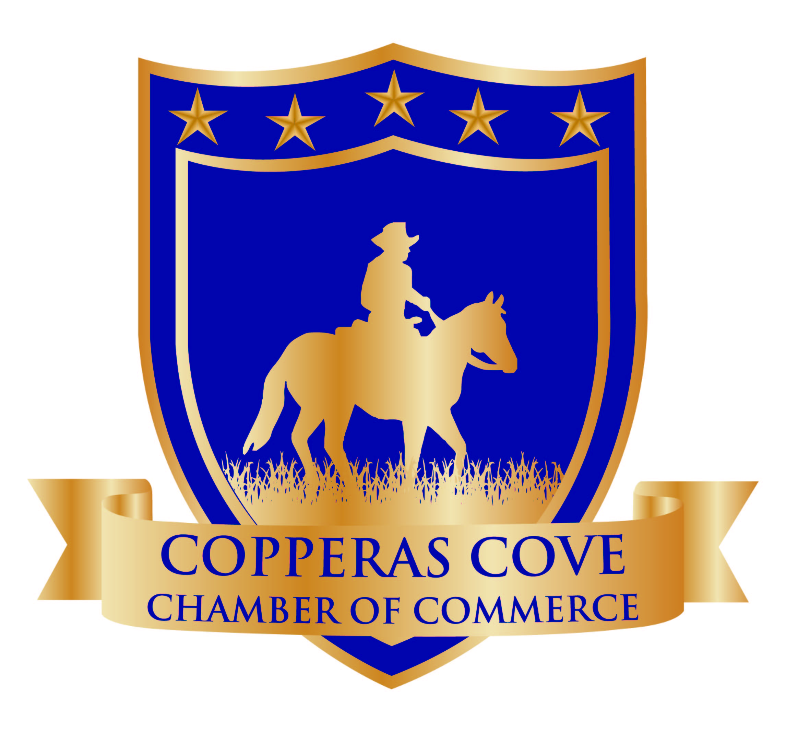

AMBASSADOR APPLICATION

Upon completion of this application, you will be considered for acceptance into the Chamber Ambassador Program, a group of professional volunteers that serve the Chamber by sharing knowledge about Chamber services, programs, and activities and by spreading enthusiasm about Chamber involvement and participation. Chamber Ambassadors serve as “sponsors” or “business liaisons” to prospective and newly-recruited members of the Chamber, help to improve communications with new members, and help increase the number of renewing members.
Application submission does not guarantee acceptance into the Ambassador Program. Each applicant will go through a selection process and will be voted on by the other Ambassadors. The Ambassador Liaison will contact each applicant regarding his/her acceptance or denial.

Name
Home Address / / /
Street City State Zip
Work Address / / /
Street City State Zip
Home Phone (_____) Work Phone (_____)
Fax Number (_____) Cell Number(_____)
Email Address
If married, spouse’s name:
EMPLOYMENT
Present Employer
Title or Responsibility Since (date)

Explain why you want to be a Chamber Ambassador:
Do you work or own a business in Copperas Cove? If so, what is the name of the business, your profession, and duties?

- Please give a brief description of what you perceive as your “positive attributes”.
- What three (3) contributions would you make if selected as an ambassador to the Copperas Cove Chamber of Commerce?
- Why do you wish to be an Ambassador?
- Which three (3) of the following twelve attributes best describes you? (Number 1-3 with 1 being the highest)

_____ Leader _____Follower _____Time Conscious ____Passive
_____Organizer _____Team Player _____Committed _____Patient
_____Aggressive _____Creative _____Assertive _____Winner
**As an Ambassador, I understand that there will be a commitment of my time and support to the various events held by the Chamber.

Signature Date

On behalf of the Copperas Cove Chamber of Commerce, we thank you for your interest in the Ambassador Program!

Community Activities

List key community, civic, professional, business, social, and other organizations of which you have been a member within the past five (5) years.
Organization Approximate Dates Position Held
Of Membership

Special Honors or Awards:
Commitment
I understand that the Ambassadors act as the public relations group for the Copperas Cove Chamber of Commerce. I have read the Ambassador guidelines and fully understand the commitments and agree to be bound by them upon signing this application.

/
Applicant Signature Date

Employer Commitment

This applicant has the approval and full support of this firm which includes the time to participate in the Chamber Ambassador Program.

/
Signature Title

