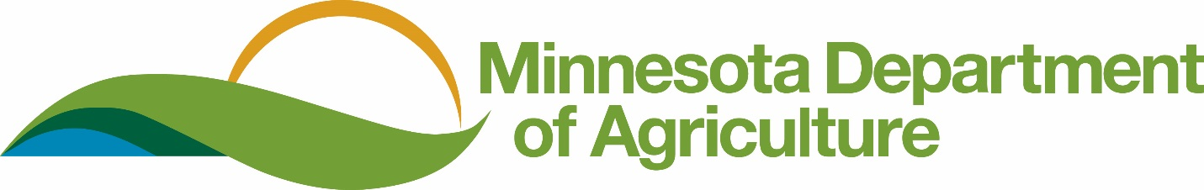

2017 Budget Initiatives

Continuous Improvement – IT Investment - $1.5 million (General Fund)
This proposal addresses the agency need to improve internal business processes and outward facing customer service. The MDA has no direct funding support for Continuous Improvement efforts and as a result has fallen behind other agencies in delivery of electronic services to our customers and in providing tools for our workforce. This proposal will allow us to identify key business needs and improve delivery of services to our customers, stakeholders and partners.
Plant Pathogens and Pests – Critical Core Capacity - $1 million (General Fund)
The MDA seeks an increase of $1 million in the agency general fund operating budget to expand current capabilities for rapid detection, identification, containment, control, and management of high priority plant pests and pathogens. The speed at which threats to agriculture now spread around the world has never been greater due to changes in markets and global distribution pathways. The requested funding will allow the MDA to hire and bolster the capacity of the MDA to more quickly identify and respond to new pests and pathogens.
Noxious Weeds - $600,000 (General Fund)
This recommendation would provide funding for needed resources and trained staff to continue oversight and enforcement of Minnesota’s Noxious Weed Law and Plant Protection Statutes. The recent discovery of highly invasive Palmer amaranth into Minnesota through native seed mixes underscores the need for a strong, proactive noxious week program. This proposal will address the protection of agricultural and conservation lands, pollinator habitats, natural areas, and other private and public lands through the state from the impacts of invasive terrestrial plants.
Developing Minnesota’s Next Generation of Crops - $2 million (General Fund) in FY 2018-19
Agronomic and food researchers have worked to develop high value commodity crops to increase market opportunities for Minnesota farmers and address conservation issues. The goal of the recommendation is to implement and market perennial and cover cropping systems specific to Minnesota that will protect and restore the state’s surface and groundwater resources while increasing efficiency, profitability and productivity of Minnesota farmers.

Industrial Hemp Development - $400,000 (General Fund)
The MDA seeks permanent funding to establish a program to oversee the regulatory and licensing responsibilities of the Minnesota Industry Hemp Development Act (MS 18K). This funding will enable us to provide adequate resources for licensing and registration of growers, on site field inspections, testing and research, and other activities associated with the current industrial hemp program established in 2016. This proposal will help determine the viability of an industrial hemp industry in MN which could be a significant alternative market for farmers
Pollinator Protection Account - $1 million (General Fund), $500,000 (Dedicated)
The creation of a Pollinator Protection Account would ensure dedicated funds are available to increase protection of Minnesota’s pollinator populations from negative pesticide impacts. The Pollinator Protection Account would support research on the economic threat of crop pests, the development of an education campaign on pesticide use, and pesticide stewardship materials. The goal is to decrease pollinator exposure to pesticides through a reduction in pesticide use. The dedicated portion of this proposal would be funded by fee revenues from pesticides toxic to pollinators.
Waste Pesticide Collection Fee Increase - $1.7 million (Dedicated)
The MDA proposes an increase on the waste pesticide surcharge paid by firms distributing pesticides. This increase will cover rising disposal and collection costs for waste pesticides collected through cooperative agreements and MDA sponsored collections. Program costs exceeded revenues last year by approximately $400,000 as the amount of non-agricultural waste pesticides continues to rise.
The fee proposal raises the waste pesticide surcharge on approximately 10,000 non-agricultural pesticides from $50 per product registered to $125 per product registered. The proposal also raises the waste pesticide surcharge on 3,650 agricultural pesticides from $50 per product registered to $75 per product registered.
Food Certificate Fee Account - $220,000 (Dedicated)
The MDA proposes a change to the funding mechanism, from General Fund to a Dedicated Account, for the administrative processing and inspection for the issuance of Certificates of Free Sale. This is an existing inspection program that provides documentation that some foreign governments and buyers require from Minnesota food exporters that certifies their products have been sold freely throughout the state. This proposal would create a dedicated fee account for Certificates of Free Sale and increase the fee for each original certificate from $75 to $125. The number of requests for Certificates of Free Sale increases about 10% annually. A dedicated account would support the administrative and inspection needs associated with this activity and decrease the amount of time needed to respond to these requests.
Clean Water Activities – $17.616 million (Clean Water Fund)
Budgetary proposals for our Clean Water Fund initiatives are provided on a separate handout.

