Larry Gunderson
Pesticide and Fertilizer Management Division
Minnesota Department of Agriculture
625 Robert Street North
St. Paul, MN 55155

Dear Mr. Gunderson,

This letter is in response to the MDA’s informal request for comments on the proposed nitrogen fertilizer rule. After numerous meetings and interactions between Minnesota Crop Production Retailers members, Certified Crop Advisors, and the Minnesota Department of Agriculture representatives, we have four major recommendations:

  - Eliminate Part 1 of the proposed rule.
  - Increase support for continued BMP development and implementation while recognizing that precision agriculture adoption is a primary vehicle which modern production agriculture is utilizing to improve fertilizer use efficiency and substantially reduce environmental risk including ground water.
  - Refine the township testing program to ensure that results reflect actual groundwater conditions without the influence of well condition problems
  - If Part 1 is not eliminated, we highly recommend MDA substantially change the fall P limitations.

Minnesota fertilizer retailers, agronomist, certified crop advisors, and growers are committed to helping ensure the safety of drinking water, now and into the future. They are also committed to continuing to provide for a hungry world. Safe drinking water and a prosperous agricultural industry can co-exist, in fact, they must.

While MCPR supports the stated intent of the proposed rule to help insure that nitrogen fertilizers are used as efficiently as is practicable, we strongly disagree with the approach taken in Part 1 of the proposed rule. As has been frequently stated by MDA staff at the listening sessions regarding the proposed rule, farmers are already adopting the “right time” recommendations as promoted through the fertilizer industry’s 4R program and supported by University of Minnesota research at a very high rate on those soils generally considered to be vulnerable to groundwater contamination. There is no need for Part 1 of the proposed rule.

Furthermore, Part 1 may serve to increase water pollution as an unintended consequence. MDA staff have heard testimony that portions of Part 1 of the proposed rule will encourage less precise placement of soil nutrients according to the nutrient need of each portion of the field which will motivate growers to select less precise application, reduced cost application products and services and thereby actually decrease nutrient efficiency and increase water pollution in some cases. MDA could well move “backward” precision agricultural advances rather than promote more advanced nutrient practices.

At your listening sessions, you have heard loudly and clearly from many farmers and agronomy professionals expressing concerns with the Ksat approach outlined in the proposed rule. There are also concerns with the subjective definition of vulnerable soil based on bedrock or karst “near” the surface.

You have also heard many examples of various farming practices being recommended which are used by farmers that encompass all the 4R principles which include the right rate at the right time in the right place using the right form of fertilizer. Building from a research base begun at land grant universities and now expanded to include industry and on-farm research, farmers continue to fine tune nitrogen rates, adjust timing and utilize products that reduce risk of nitrogen loss. Promotion of research and education to further develop and demonstrate beneficial nitrogen management practices has been effective in the past and strongly supported by Minnesota Agriculture through such voluntary efforts as the Agriculture Fertilizer Research and Education Council. we believe that increased support for these efforts would do more to protect groundwater and improve farm sustainability than will Part 1 of the proposed rule.

MCPR appointed ag professions who served on the task force that assisted the MDA in updating the Nitrogen Fertilizer Management Plan. We believe that during the lengthy discussion that took place over about two years and 18 meetings, great emphasis was brought to creating a statewide framework only from the perspective of addressing groundwater nitrate issues wherever they occur in the state, with any remediation efforts focused on the specific areas where groundwater nitrate levels are elevated as outlined in part two of the proposed rule. In fact, the question was asked several times, “will your efforts expand into areas beyond the irrigated sands and karst regions?” and the answer was always “no, we just don’t see problems there.” How then did we get to the vulnerable soils map associated with the proposed rule?

Given the significant problems with the methods used to generate the vulnerable soils map, the most practical solution is to delete Part 1 of the proposed rule and all language associated with it entirely.

Throughout the development of the updated Nitrogen Fertilizer Management Plan and in the MDA’s presentations on the proposed rule, much emphasis has been placed on the involvement of local advisory teams, especially farmers and their nutrient management advisors. The requirement that local advisory team members “provide support” to the commissioner for the implementation of the response activities should be deleted. As stated in the name, the function of the team is to “advise” the commissioner, not provide funding for this regulatory program.

About part two of the proposed rule, there are significant concerns with the current approach. First, the Township Testing Program County reports show that in some townships the number of wells is very small, sometimes due to a low number of wells and sometimes due to low participation. We propose that the MDA put forth greater effort targeting those areas in Level 2, 3 and 4 to ensure that all residents are made aware of groundwater conditions in the county by requiring that at least 80% of wells in the township be tested and screened for potential non-fertilizer nitrate sources prior to level 2, 3 or 4 designations.

It is also very important that the MDA provide greater emphasis on the difference between initial and follow-up sampling, as first round results can be misleading. It is important for all residents in affected areas to know that their drinking water is safe. It is also extremely important for all stakeholders to know that wells that may be influenced by nitrate sources other than fertilizer are NOT being used in the determination of mitigation level. Township well testing reports should not be released until after round two testing has been completed and all ineligible wells have been removed from the calculation of mitigation level.

Subpart 2 C
For some farmers, a common practice is the fall application of phosphate in a quantity that is sufficient to meet the needs of a 2-year corn/soybean crop rotation usually applied for the corn growing year. This practice reduces fuel consumption, and soil compaction by reducing the number of trips across a field, and reduces time and labor costs. 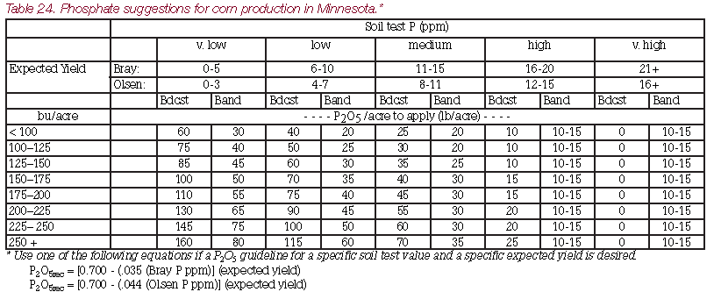
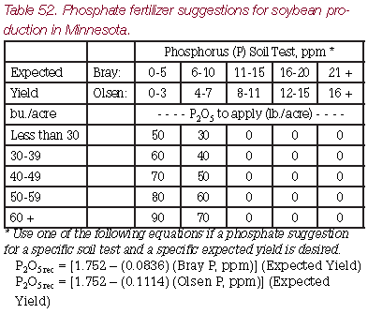
Some of the low to medium testing soils with average or better yield expectation could need in the range of 150 lbs. P2O5/ac to meet the crop requirements for the 2-year corn/soybean rotation. The amount of nitrogen delivered (approximately 30 lb./ac of N) with this application would be accounted for in determining the correct N rate applied for the corn so the N rate would not be over applied. An exception for the application of agronomically appropriate rates of phosphate to meet the needs of a 2-year corn/soybean rotation should be included in the exceptions under Subpart 2C.
Potash is also commonly applied in the same operation with the phosphate application. If there is no exception made for agronomically appropriate rates of fall applied phosphate for a 2-year corn/soybean rotation then farmers will need to apply and retailers will need to be able to deliver on average an additional 75 lb./ac of P₂O₅ and 75 lb./ac of K₂O each spring (based on potash rates between 50 and 150 lb./ac for soybean and corn average needs).
The ability of farmers and retailers to deliver and apply the additional volume of phosphate and potash fertilizer product to be applied in the spring could be further constrained by the switch of nitrogen application from fall to spring and the change from fall anhydrous ammonia to spring urea or UAN with its lower N analysis resulting in higher volumes to meet the same N requirement.
Subpart 6 – Fall Application uses the term “inorganic nitrogen fertilizer”. Nitrogen fertilizer is defined in subpart 13. Would the addition of the word inorganic in subpart 6 mean that the rule would allow for the addition of manipulated organic fertilizer after Aug. 31st? All Nitrogen fertilizers should be treated in the same way, regardless of whether the N source is organic or inorganic, since all nitrogen sources are potential nitrate sources. The term “inorganic” should be removed from the definition in Subpart 6.

The MDA has a role in setting appropriate expectations with the public about the time frames around expected water quality improvements. Lag times for water quality changes mean that nitrate well monitoring results are not necessarily indicative of the management practice changes that have occurred over the last 5-10 years. The emphasis on well water monitoring for changes in nitrate levels in a 3-year time is sending a message to the public that the department expects to see changes to water nitrate levels in a short time period. This creates potential for unmet public expectations and rising concerns leading to more restrictive regulations on fertilizer use that may or may not reduce nitrate levels in the 3-year period. The education component under the water resource requirements must also include public education on the timeframes for expected changes in water quality and other factors that affect nitrate levels in monitored wells. The proposed rule should include a requirement to fund education efforts for all stakeholders.
We are concerned about the complexity of evaluating nitrogen management practices. While we support the commissioner’s intent to ensure that farmers are using nitrogen as efficiently as possible, factors such as weather greatly influence crop growth and nitrogen uptake. We are concerned that the general recommendations currently found in University of Minnesota’s BMPs are not well understood and there is a fear that the MDA may set unreasonable nitrogen rate limits through this regulation. An important factor in allowing the precision agriculture to determine fertilizer application practices and rates is the acknowledgement of “on-farm trials” according to appendix 6 which are included in as necessary method of truth testing the University of Minnesota BMPs standards. This issue is compounded by the fact that the MDA has taken on a larger role in nutrient management education by choosing to add nutrient management staff within its own ranks. MDA staff must be able to work with precision ag programs to be able to manage the University BMP recommendations within the frame work of “on-farm trials”.

As it takes on a larger role in regulation, the MDA should provide additional funding to the University of Minnesota and Extension and agricultural organizations for the purposes of BMP research and education. Direct MDA activities should be confined to the regulatory functions being created, specifically water monitoring and BMP adoption assessment.

If you have any questions or would like to discuss these comments, feel free to contact me.

Bill Bond
Bill Bond, Executive Director
Minnesota Crop Production Retailers
15490 101Ave N, Suite 100, Maple Grove, MN 55369
Off. Direct Ph. 763-235-6472, www.mcpr-cca.org, bill@mcpr-cca.org

