BRAZOS COUNTY There's been a major shakeup inside a local volunteer fire department.
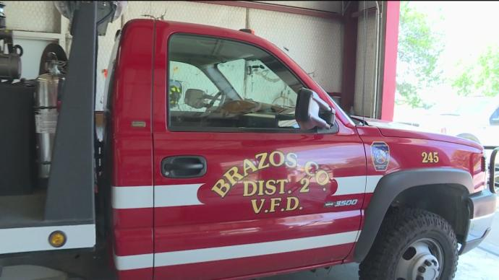
The fire chief for the Brazos County District 2 Volunteer Fire Department, along with several others, resigned from their positions due to internal conflicts.
KBTX has learned several issues have divided the department including a convicted arsonist being allowed to be part of the team and disagreements about training mandates for volunteers.
District 2 provides emergency services for residents in the northeast part of Brazos County including Kurten, Tabor and Wixon Valley.
Due to the turmoil, several firefighters have been pushing for the removal of Merrie Noak from her position as fire chief.
Noak was one of several members of a board that approved allowing a convicted criminal with several felonies including arson, burglary and impersonation of a police officer to join the agency.
Some firefighters say Noak knew the firefighter had felony convictions on his record. They consider it to be a public safety threat to have someone with his kind of background responding to emergency calls.
"It's imperative that anyone that's a first responder that's going to help people in the community, going into people's homes, going to disaster scenes have the highest integrity and moral level," said Donald Hendricks, a former firefighter for District 2.
"We can't risk having someone go to an emergency and have them stealing and doing something they shouldn't be doing," Hendricks said.
After joining the department earlier this year, Hendricks says he was voted out after expressing concern about Noak's decision to allow the firefighter on board.
Hendricks, and others, have also expressed concern about the training requirements set by the department and its board. He says Noak wasn't doing enough to train new firefighters, but others including the department's captain, say training to be a first responder should never be rushed.
"That's the one thing I commend Merrie Noak on doing," said District 2 Captain Danny Harvell.
"Her main thing was making sure we were safe and making sure we had the proper equipment to do our job for the community," said Harvell.
Hendricks said he was on board the fire department for three months and was never allowed to respond to calls or use some of the gear.
Captain Harvell says training can sometimes take one or two years for new volunteers.
The department's executive board will have an emergency meeting in the coming days or next week to address the resignations and appoint a new fire chief.
"It's imperative that anyone that's a first responder that's going to help people in the community, going into people's homes, going to disaster scenes have the highest integrity and moral level," said Donald Hendricks, a former firefighter for District 2.
"We can't risk having someone go to an emergency and have them stealing and doing something they shouldn't be doing," Hendricks said.
After joining the department earlier this year, Hendricks says he was voted out after expressing concern about Noak's decision to allow the firefighter on board.
Hendricks, and others, have also expressed concern about the training requirements set by the department and its board. He says Noak wasn't doing enough to train new firefighters, but others including the department's captain, say training to be a first responder should never be rushed.
"That's the one thing I commend Merrie Noak on doing," said District 2 Captain Danny Harvell.
"Her main thing was making sure we were safe and making sure we had the proper equipment to do our job for the community," said Harvell.
Hendricks said he was on board the fire department for three months and was never allowed to respond to calls or use some of the gear.
Captain Harvell says training can sometimes take one or two years for new volunteers.
The department's executive board will have an emergency meeting in the coming days or next week to address the resignations and appoint a new fire chief.

