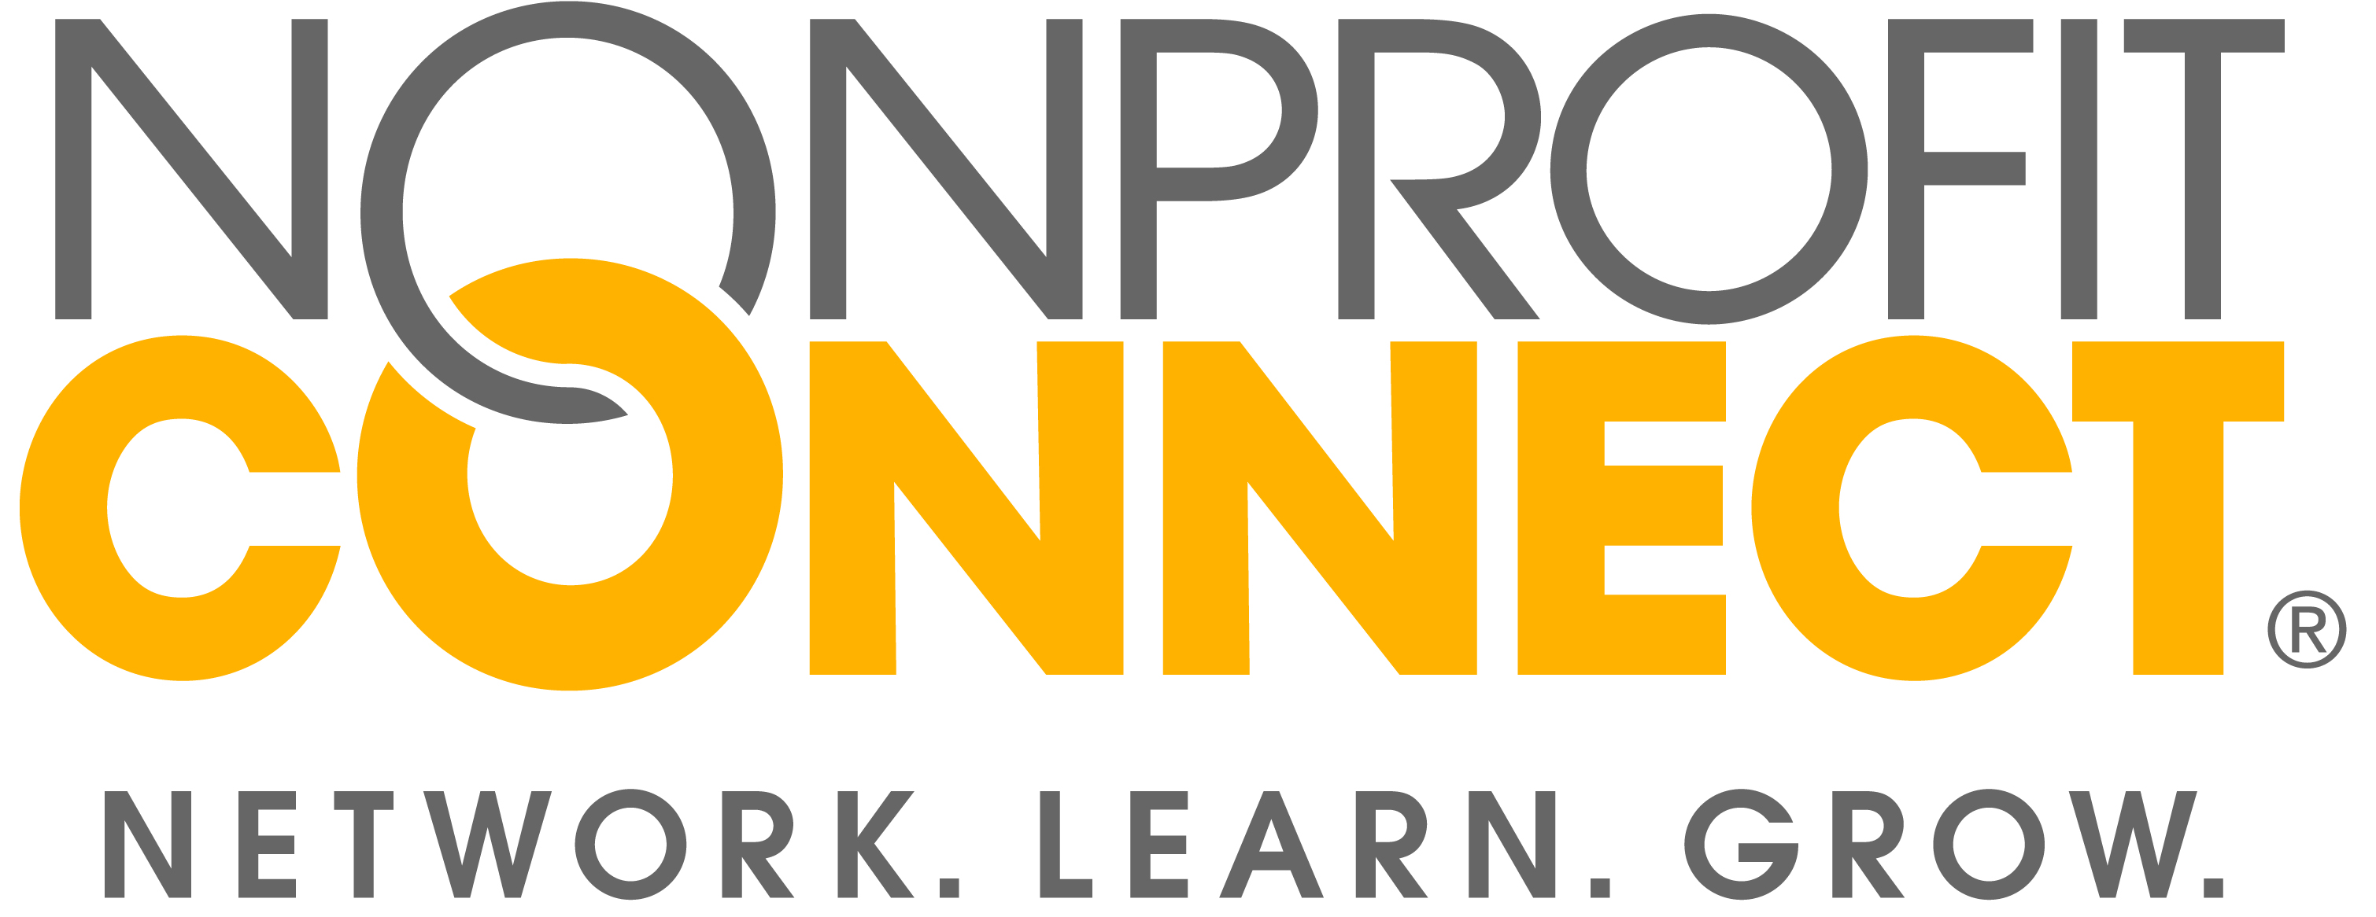
__________________________________________________________________________________________________

FOR IMMEDIATE RELEASE FOR MORE INFORMATION CONTACT:
December 12, 2017 Jackie Baker, Director of Marketing
(816)-888-5605
jbaker@npconnect.org

Kansas City nonprofits raise over $1.4 million on #GivingTuesday

Kansas City, MO – On #GivingTuesday, Kansas City nonprofit organizations reportedly raised over $1.4 million from 7,488 donors. These results were compiled from a survey issued by Nonprofit Connect to nonprofit organizations based in the Kansas City metro.

129 different nonprofit organizations reported results from the international day of giving, including the amount of funds they raised and the amount of donors that gave to their organization. Organizations also reported that 90% of the funds raised on #GivingTuesday support Kansas City programs. The other 10% support national and international efforts.

Nonprofit Connect, a local professional association for nonprofit organizations, issued the survey after they realized that there were many national statistics on #GivingTuesday results, but no statistics specific to Kansas City. The organization hopes that this data will help to elevate the day of giving in the Kansas City community, and create an even bigger buzz for #GivingTuesday in 2018.

Nonprofits shared why the organization chose to participate in #GivingTuesday, how they promoted their campaign, what their goals were, and whether they hit those goals. The complete results are listed in an infographic at https://www.npconnect.org/givingtuesdaykc.

Highlights:
- On average, each organization received gifts from 69 donors.
- 10 Organizations reported that this was their first year participating.
- 66% of organizations reported raising under $10,000
- Of the 69 organizations that reported both a measurable goal and results, 69% reported hitting or exceeding this goal on #GivingTuesday.

“$1.4 million makes a huge difference for Kansas City nonprofits. By giving back to local organizations, we are making a statement about what kind of community we want to live in and take action to support and improve Kansas City,” said Luann Feehan, Executive Director of Nonprofit Connect. “Kansas Citians make a great effort to eat local and shop local. Why not make an equal effort to give local?”

Nonprofit Connect supports #GivingTuesday in Kansas City by promoting the hashtag #GivingTuesdayKC, publishing a directory of local organizations that are in need of support, and providing example social media posts and images. All these resources can be found at https://www.npconnect.org/givingtuesdaykc.
#GivingTuesday is a global day of giving that harnesses the collective power of charities, families, businesses, and individuals to encourage philanthropy and to celebrate generosity worldwide. #GivingTuesday is held annually on the Tuesday after Thanksgiving, this year on November 28, 2017, to kick-off the holiday giving season and to inspire people to take collaborative action to improve their local communities and to give back in better, smarter ways to the charities and causes they support. In 2017 #GivingTuesday raised over $274 million across the world, a new record from previous years, according to The NonProfit Times.

About Nonprofit Connect
Nonprofit Connect is a regional association for nonprofit organizations that provides professional development, resources and a career center for Kansas City’s nonprofit sector. Nonprofit Connect’s mission is to link the nonprofit community to education, resources and networking so organizations can more effectively achieve their missions.

###

